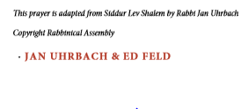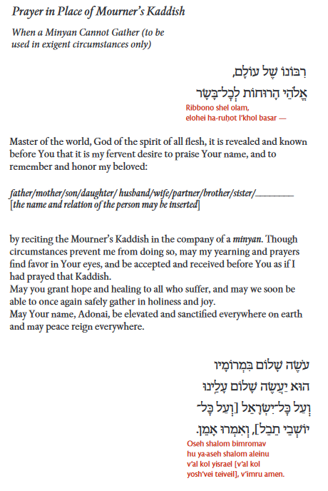

Dear Congregant,

We regret that we cannot convene at in person minyanim for you at this time. Please know we are with you mentally and spiritually. Below is a prayer that can be said to honor the memory of your loved one. We thank you for your understanding.

-CEC Ritual Committee